1. **How to create a table in SQL?**

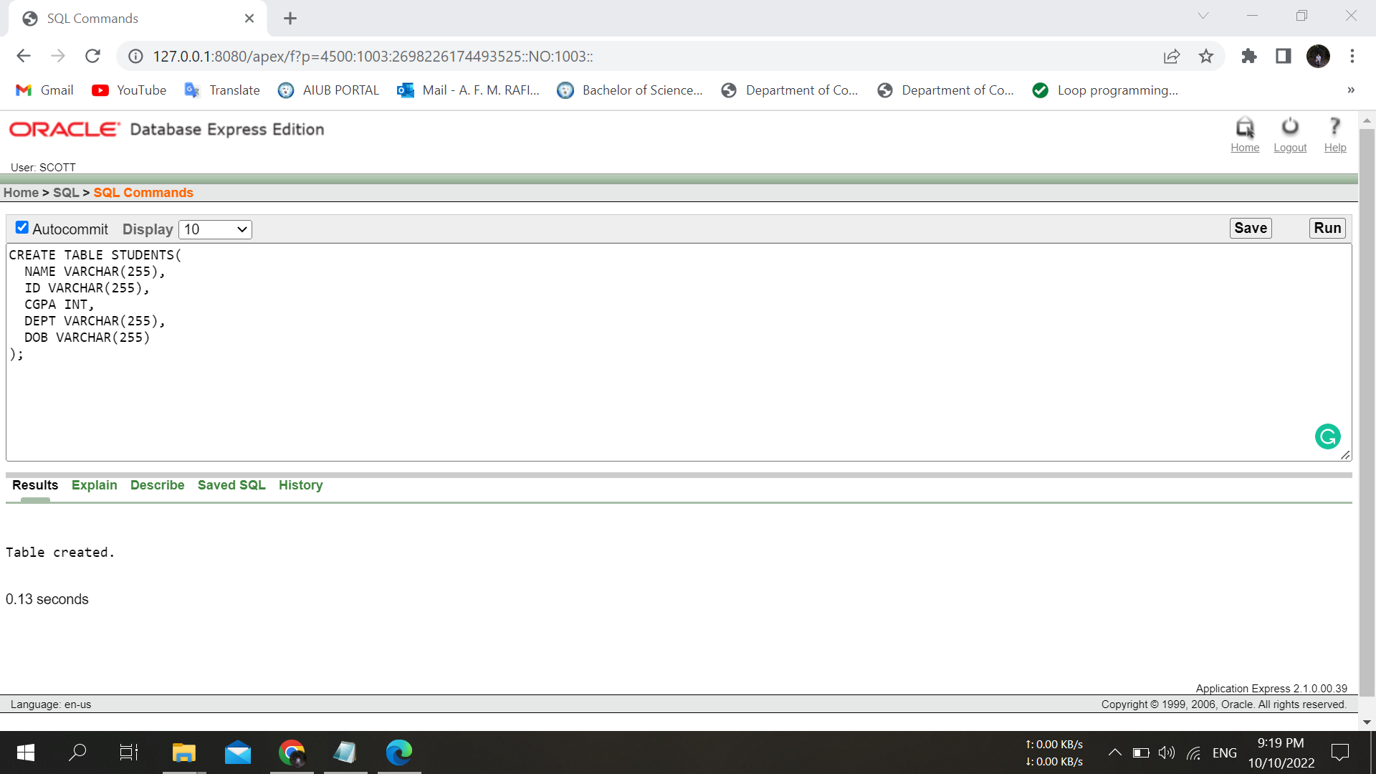

1. **How check the object type of a table?**

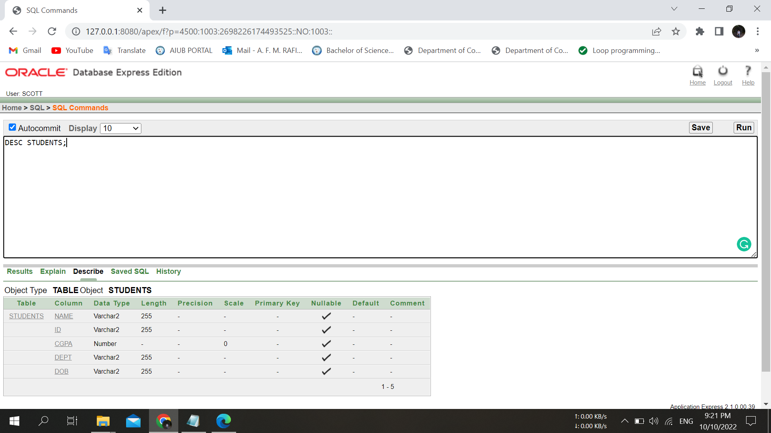

1. **How to insert values into a table?**

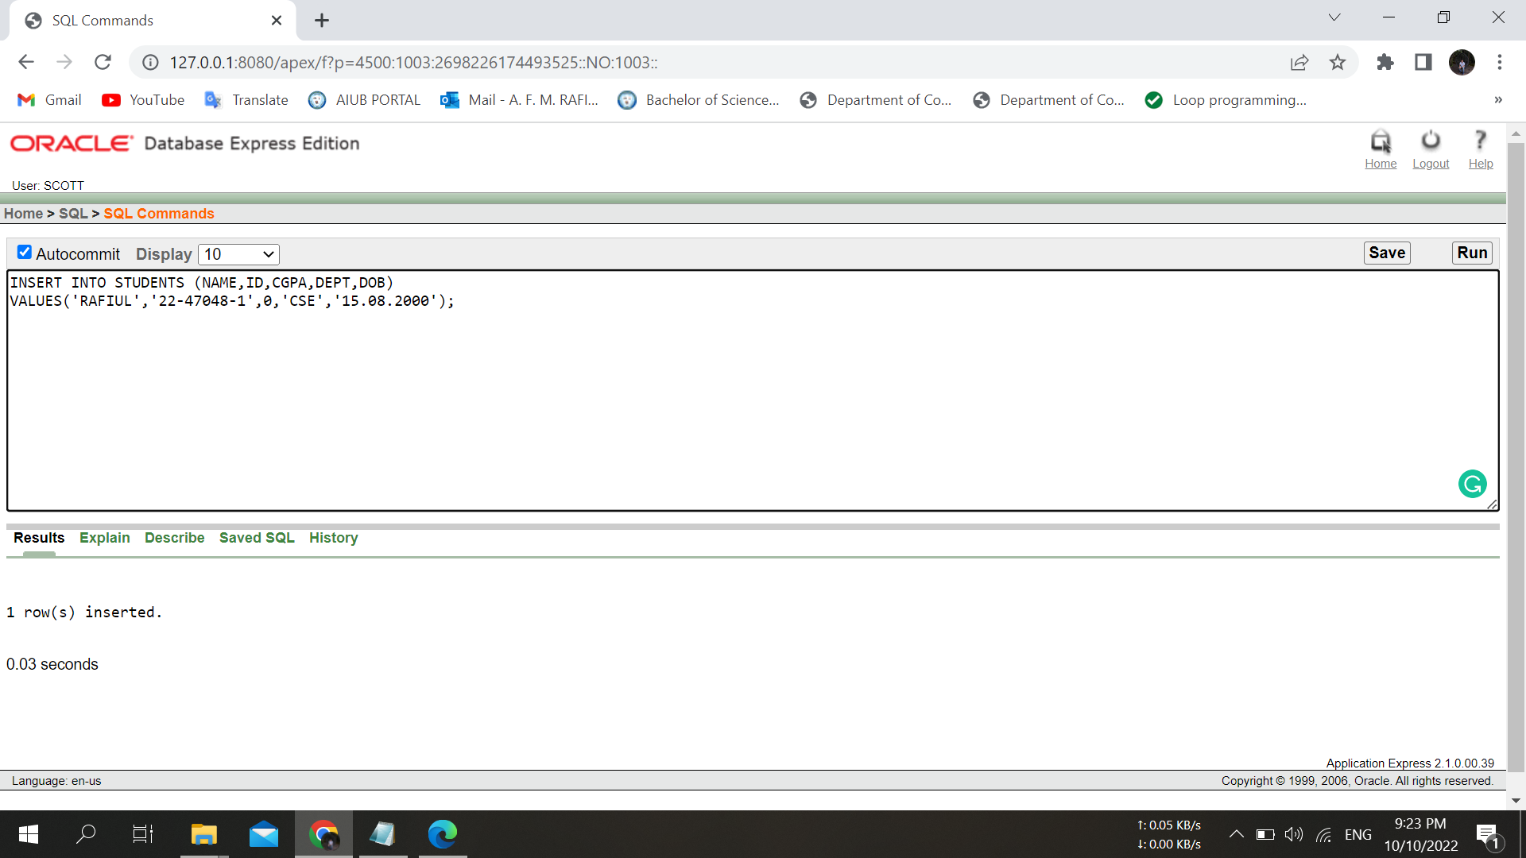

1. **How to select all columns from a table?**

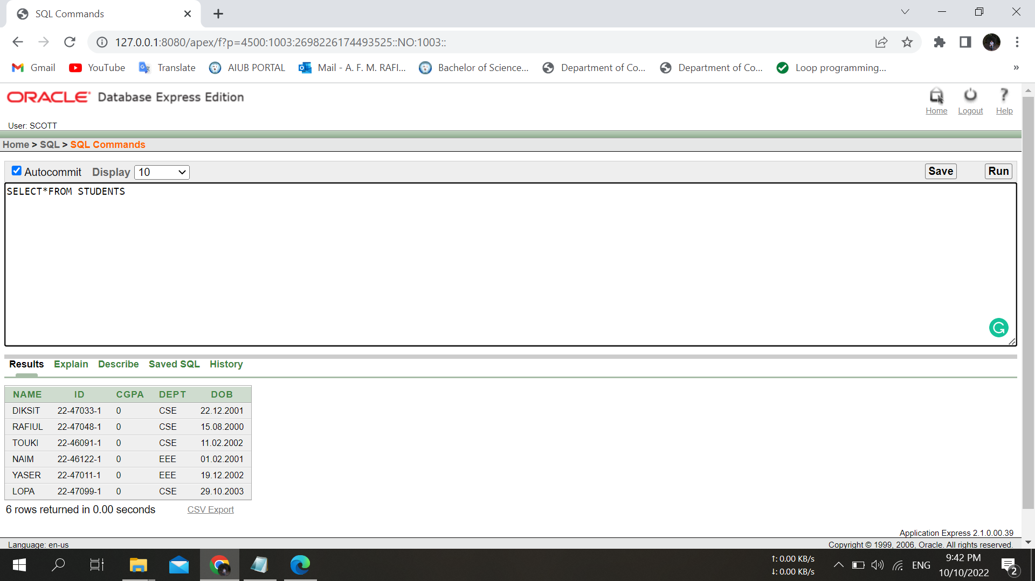

1. **How to select only one column from a table?**

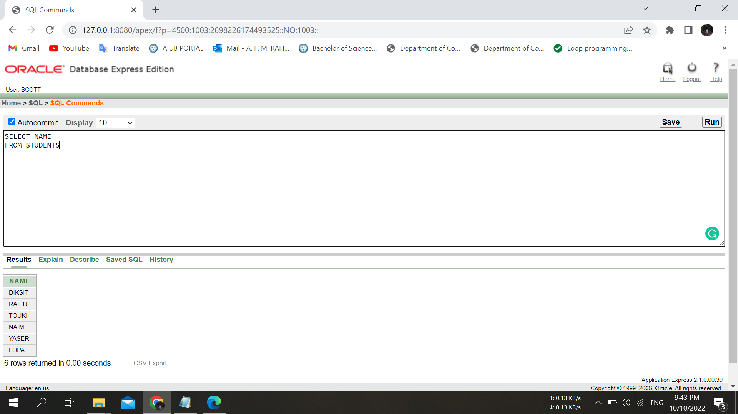

1. **How to select specific columns from a table?**

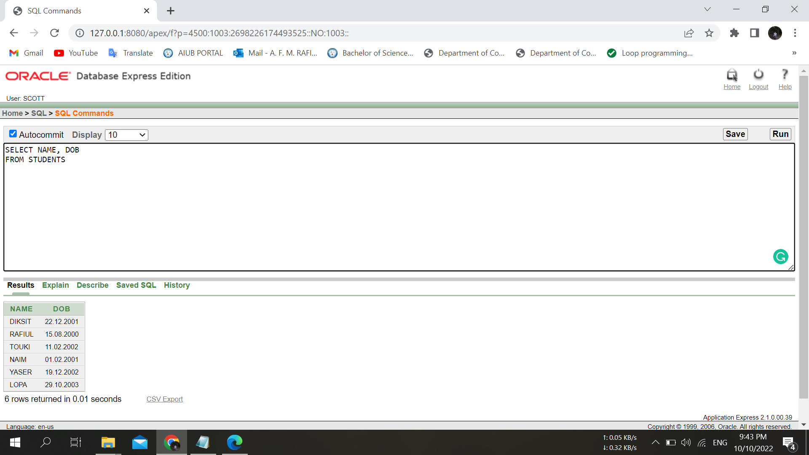

1. **How to use an arithmetic operator?**

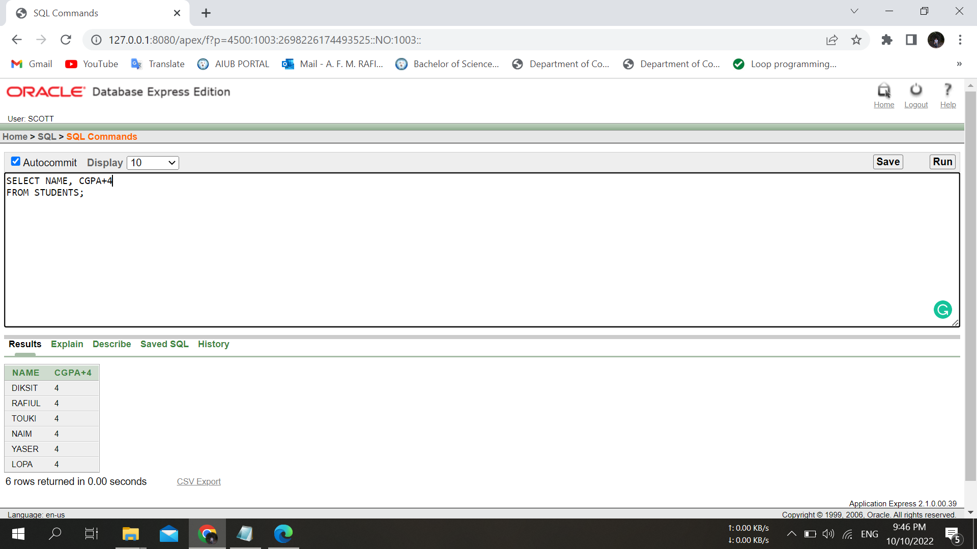

1. **How to use column aliases?**

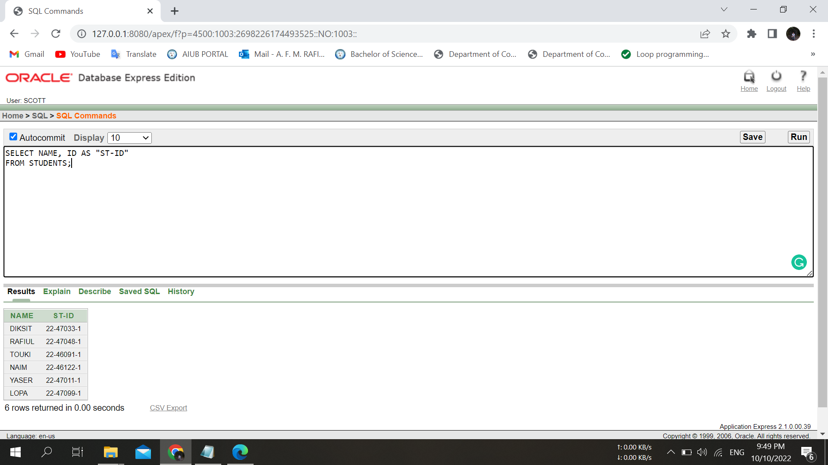

1. **How to use the concatenation operator?**

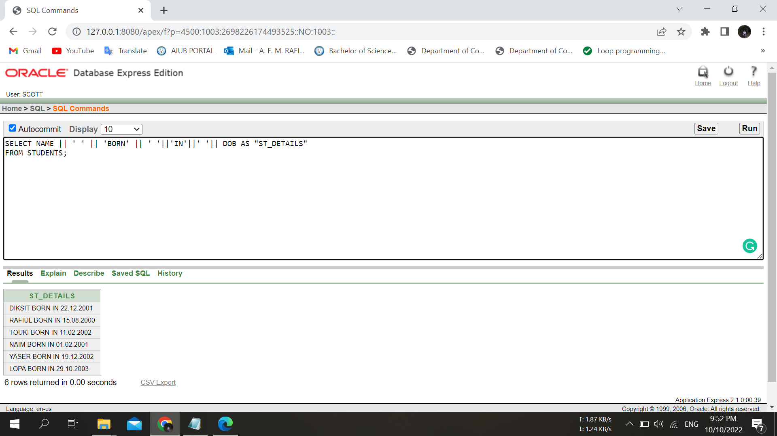

1. **How to eliminate duplicate rows?**

